**Name** : Arun  
**Roll** **number** : 21011102016

**Angular app**

Source code:

app.module.ts

import { NgModule } from '@angular/core';

import { BrowserModule } from '@angular/platform-browser';

import { FormsModule } from '@angular/forms';

import { AppComponent } from './app.component';

import { MODULENAMEComponent } from './TODOS/module-name.component';

@NgModule({

declarations: [

AppComponent,

MODULENAMEComponent

],

imports: [

BrowserModule,

FormsModule

],

providers: [],

bootstrap: [AppComponent]

})

export class AppModule { }

app.component.ts

import { Component } from '@angular/core';

@Component({

selector: 'app-root',

templateUrl: './app.component.html',

styleUrls: ['./app.component.css']

})

export class AppComponent {

title = 'todoapp';

}

app.component.html

<div clas="app">

<header>

<h1>Todo List</h1>

</header>

<app-module-name></app-module-name>

</div>

module-name.component.ts

import { Component,OnInit } from '@angular/core';

import{Todo} from './../models/Todo';

@Component({

selector: 'app-module-name',

templateUrl: './module-name.component.html',

styleUrls: ['./module-name.component.css']

})

export class MODULENAMEComponent implements OnInit {

todo: Todo[] = [];

inputtodo:string=""

constructor(){}

ngOnInit(): void {

this.todo=[

{

content:'First todo',

completed: false

},

{

content:'Second todo',

completed: true

}

]

}

toggleDone (id: number) {

this.todo.map((v,i)=>{

if(i == id) v.completed =!v.completed;

return v;

})

}

deleteTodo (id: number) {

this.todo=this.todo.filter((v,i)=>i!==id);

}

addTodo(){

this.todo.push({

content:this.inputtodo,

completed: false

});

}

}

module-name.component.html:

<div class="todos">

<form (submit)="addTodo()">

<input

type="text"

name="inputtodo"

placeholder="enter todo..."

class="todo-input"

[(ngModel)]="inputtodo"

/>

<input type="submit" value="Add Todo" class="todo-submit"/>

</form>

<div *ngFor="let todo of todo;let i= index;" class="todo {{ (todo.

completed ? 'done':'') }}">

<div class="id">{{ i }}</div>

<div class="content" (click)="toggleDone(i)">{{todo.content}}</div>

<button class="delete"(click)="deleteTodo(i)">Remove</button>

</div>

</div>

module-name.component.css:

.todo {

display: flex;

padding: 10px 15px;

background-color: #8ddecb;

border-bottom: 1px solid #2b1515;

}

.todo:nth-child(even) {

background-color: #EEE;

}

.todo:last-of-type {

border-bottom: 0;

}

.todo .id {

flex: 1 1 50px;

}

.todo .content {

flex: 1 1 100%;

}

.todo.done .content {

text-decoration: line-through;

}

.todo-input {

display: block;

width: 100%;

padding: 10px 15px;

appearance: none;

border: none;

background-color: #F3F3F3;

margin-top: 15px;

font-size: 20px;

font-family: 'Times New Roman', Times, serif;

outline: none;

background-color: azure;

}

.todo-submit {

display: block;

width: 100%;

max-width: 200px;

appearance: none;

border: none;

outline: none;

background: none;

background-color: #FE4880;

color: #FFF;

margin: 15px auto;

padding: 10px 15px;

font-size: 18px;

font-weight: 700;

}

Output in Vs code terminal:

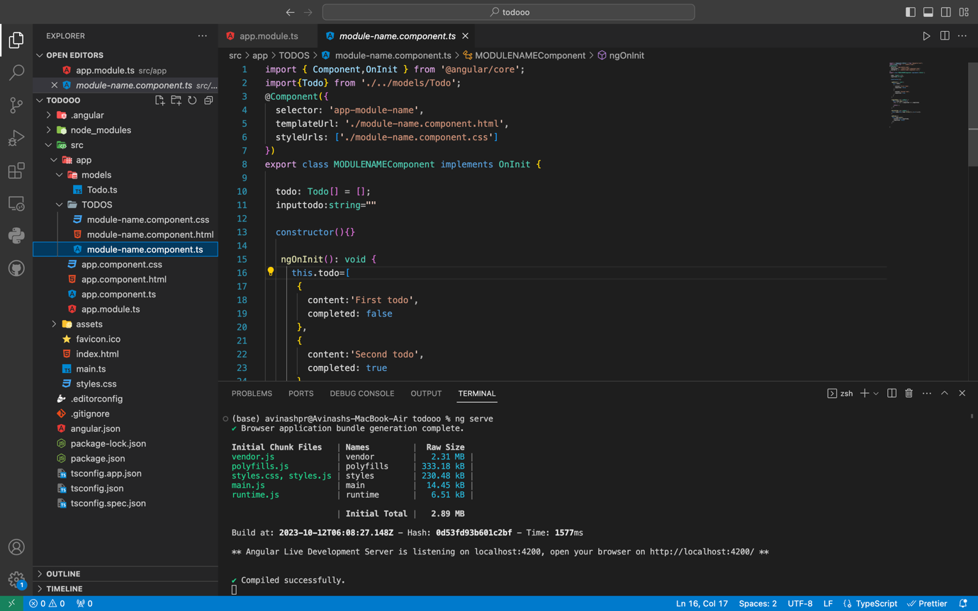

Output in localhost:4200 